Corrections 17th of March 2015

# Dashboard

Add the following links:

* AdminPanel Button on left top should always link to > dashboard
* The 4 Boxes on dashboard should link to the correct section
  + Clients > Clients overview
  + Websites > Websites overview
  + Checklists > Checklists overview
  + Messages > Messages overview

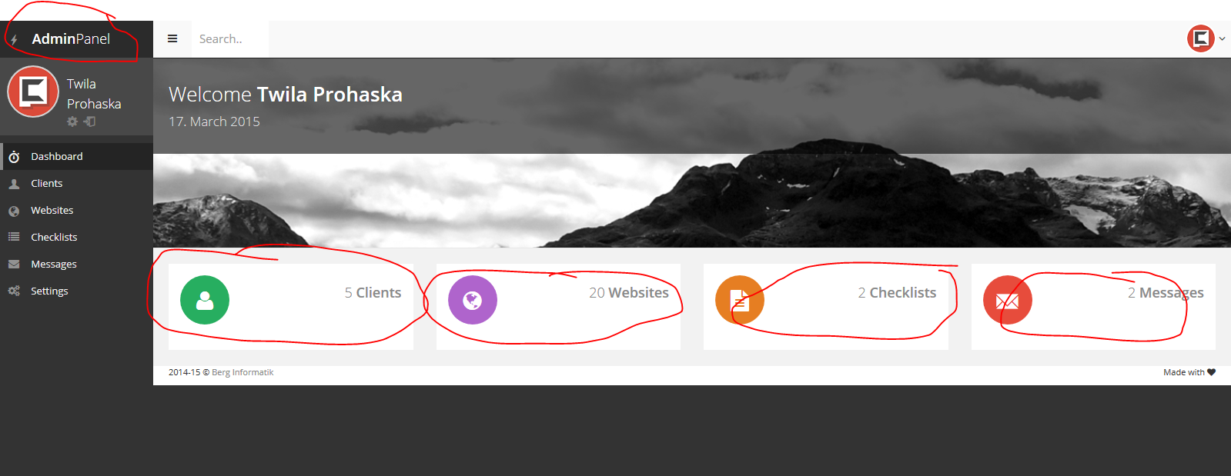

# Clients

Add correct count to All (total clients).

Add function to the categories filter > on click should filter the list of clients (same function as the a-z filter)

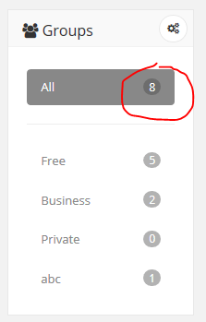

Edit Client

Add correct created, updated informations

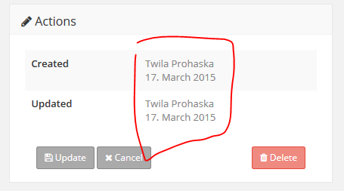

View more button should append results to list or alternate add classic pagination to these elements.

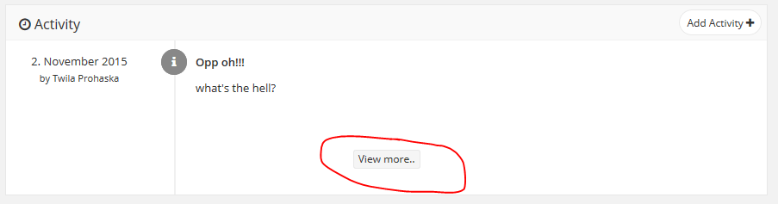

Add delete confirmation message

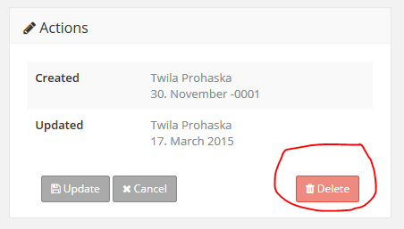

Checklist save fails

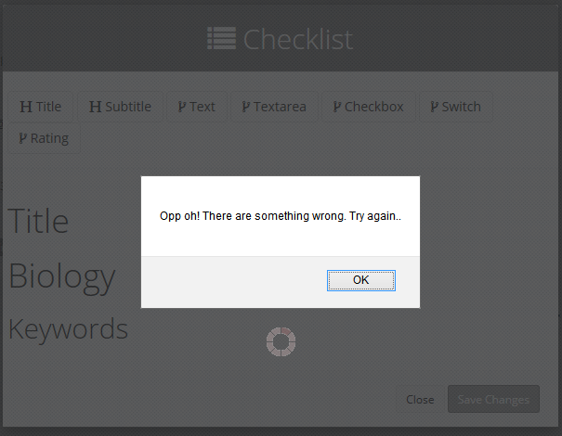

Remove buttons on Client page, because it is not possible to edit the template from the clients page.

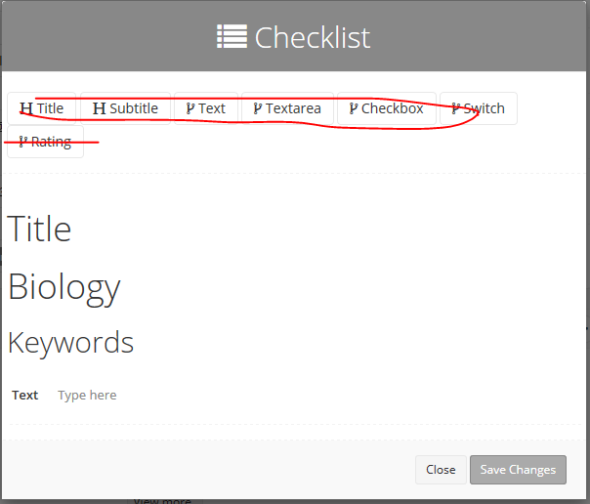

Checklist download and send to client functions fails.

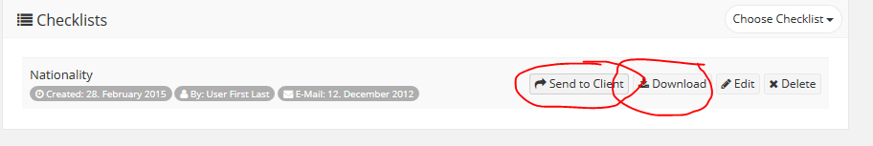

Add correct data to these labels.

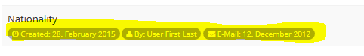

# Edit Checklist

Some buttons does not work.

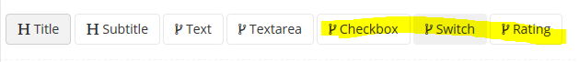

Add possibility to remove elements.

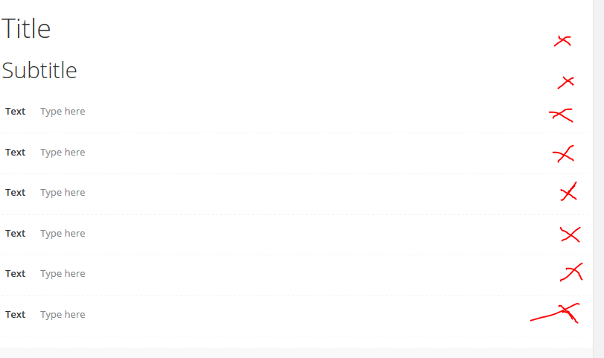

Remove double save button

